**GRADE 8 CREATIVE ARTS AND SPORTS TO BE ALIGNED TO GRADE G7**

**WEEK 1**

**STRAND 1. FOUNDATIONS OF CREATIVE ARTS.**

**Introduction to Creative Arts and Sports.**

**What is creative arts?**

* Creative Arts is a description of various artistic activities that allow performers to use their imaginations, creativity, and express ideas through a variety of mediums to pass a message to the audience.

**What are sports?**

* A sport is any activity involving physical or mental effort combined with skills in which an individual or a team or teams [compete](https://www.google.com/search?client=opera&sca_esv=601985024&bih=648&biw=1316&hl=en&sxsrf=ACQVn08ZuL9yaXpTaljCdGi6wM-spaudag%3A1706358931385&q=competes&si=AKbGX_q870E3DK3nJ7cu3BOD7pxC9Y1WacGX_mA9S28CZsKk_-K6-7NSqVX-S0S_svF1wkv7W47Mpos2txANChCAAkYoFPphxnr4xfn65fXmleVat9_Of8w%3D&expnd=1) against another or others for entertainment.

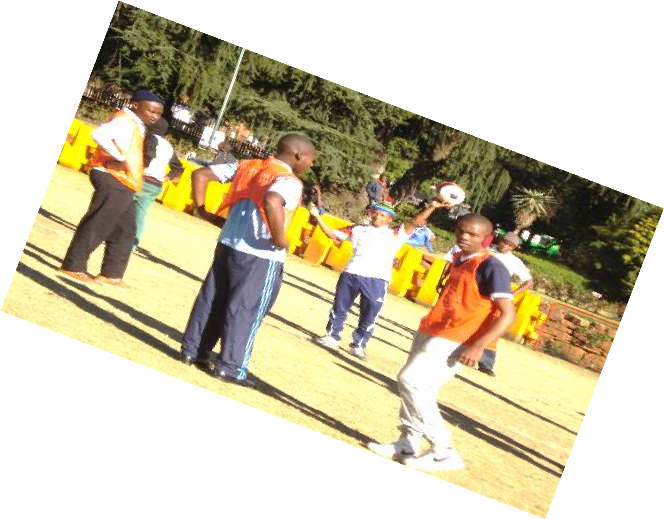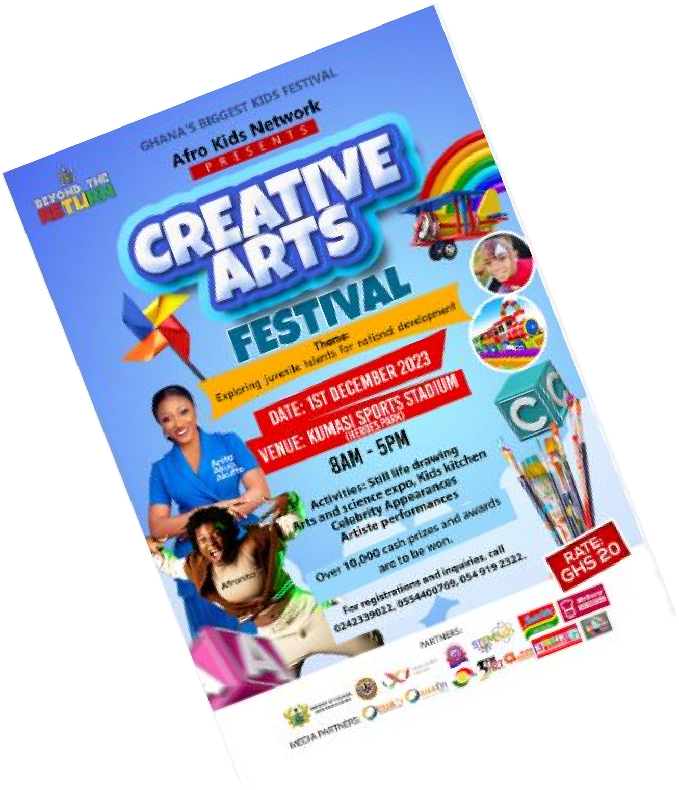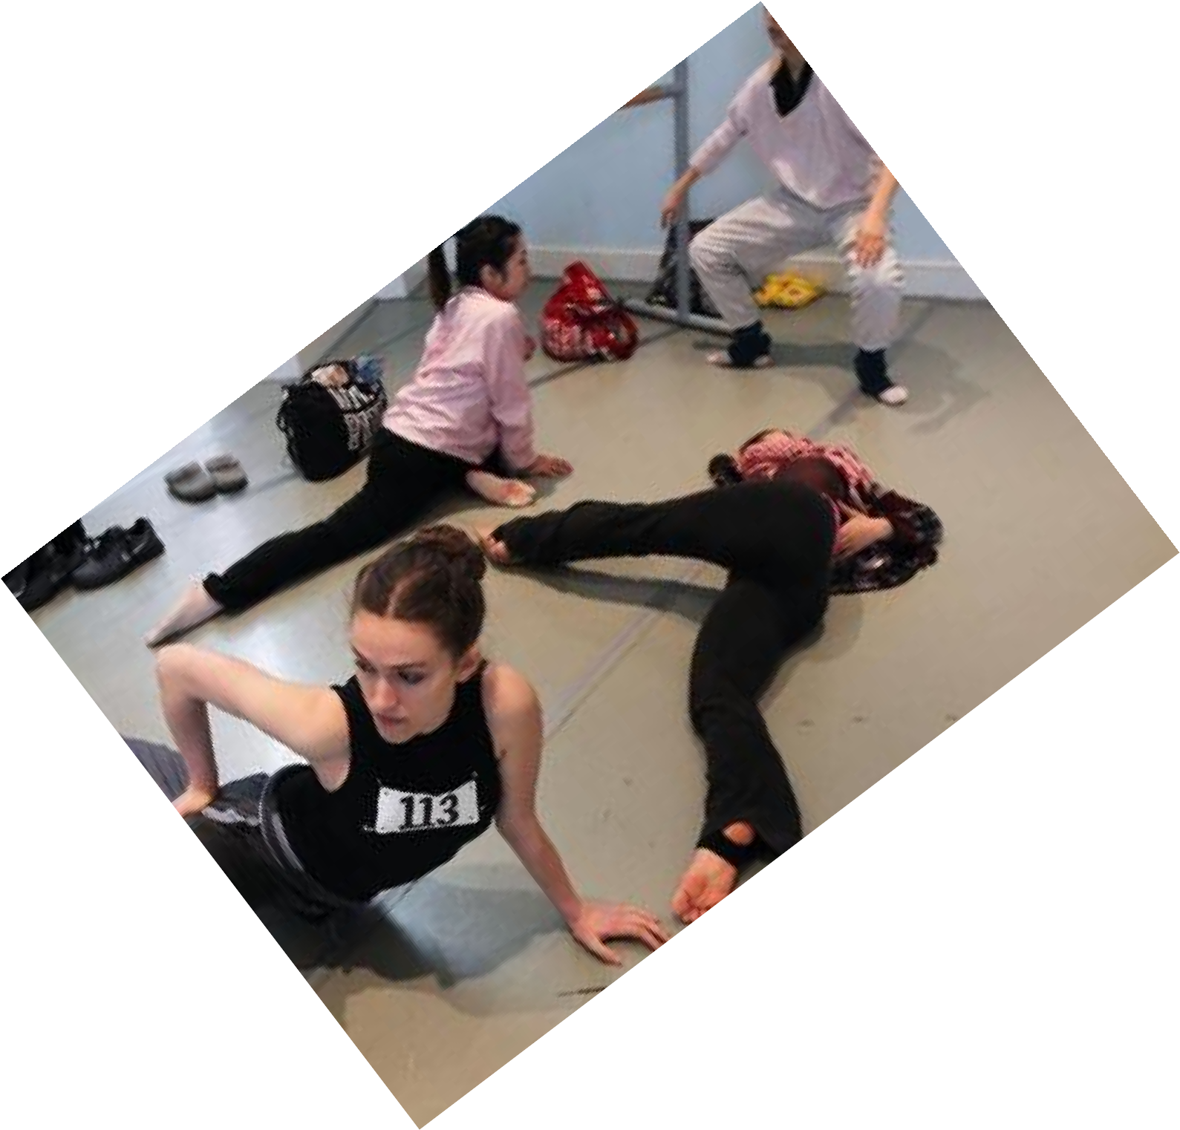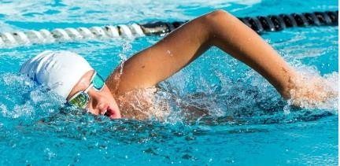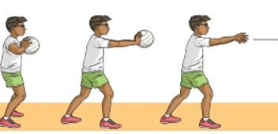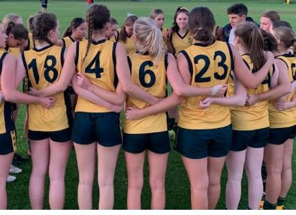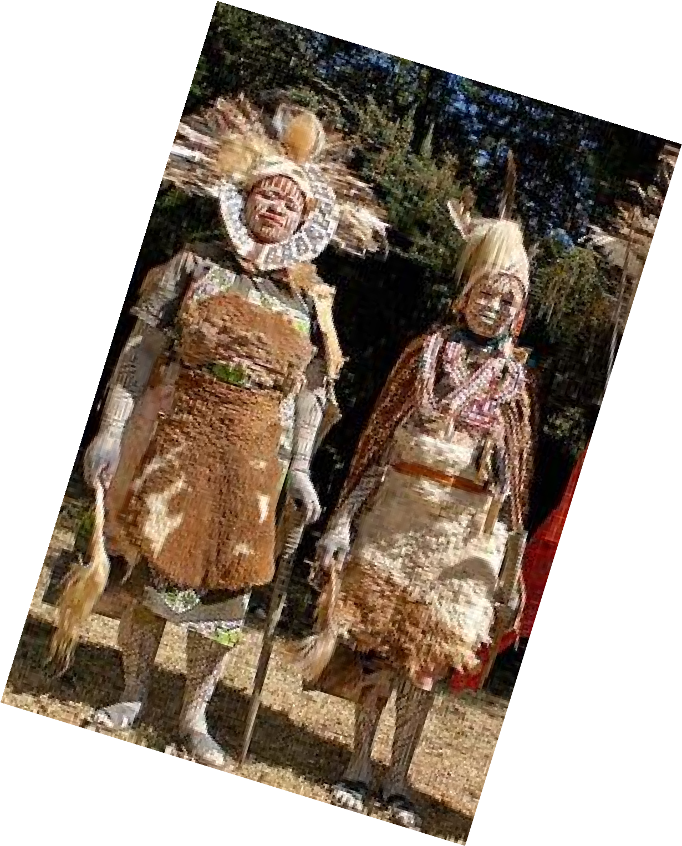

**Roles of Creative arts and sports in the society.**

**Social roles of Creative arts & Sports**

* Creates a sense of identity-bring people together, creating shared experiences that help to foster a sense of community and collective identity.
* Creative arts and sports promote cohesion through teamwork.
* Through creative arts and sports culture is preserved-it ensures that our history and traditions are not forgotten, and that future generations can appreciate and learn from them.
* Creative arts and sports inspire creativity, talents and abilities.
* Creative arts and sports provide provides us with entertainment through components such as music, dance, drama, narratives, films and movies, various sports i.e., soccer, basketball, netball, volley ball.

**Economic roles of Creative arts and Sports.**

* Creative arts and sports provide employment opportunities such as artists, musicians, referees, sports coaches, sports doctors, choreographers. Trainers, teachers etc.
* One can earn income through activities related to creative arts and sports hence eradicating poetry.
* Through creative arts and sports, a country can earn or generate tax revenue. (boosts revenue collection)
* Creative arts and sports attract investments which in turn increases job opportunities.
* Creative arts and sports stimulate growth of economy through sectors such as tourism. (Encourages tourism)

**1.2 Components of Creative Arts and Sports.**

Creative arts is made of the following components:

* Visual arts -creative art forms appreciated through sense of sight such as;
  + Drawing.
  + Painting.
  + Sculpture.
  + Montage.
  + Collage
* Play - a written work that tells a story through action and speech and is meant to be acted on a stage.
* Music - Music is a collection of coordinated sound or sounds. Making music is the process of putting sounds and tones in an order, often combining them to create a unified composition
* Dance – dance is the movement of the body in a rhythmic way, usually to music and within a given space, for the purpose of expressing an idea or emotion.

**Principles of Visual arts.**

* There are two principles of visual arts namely:
* Principle of dominance.
* Principle of proportion.

**Principle of dominance in Visual Arts.**

* Dominance is when a single element is so large and/or different compared to the rest of the design that it dominates.
* It grabs your attention.
* Famous examples include the London Eye that dominates the skyline of London or the Ashoka Lions that dominate the Indian Passport and other official documents.

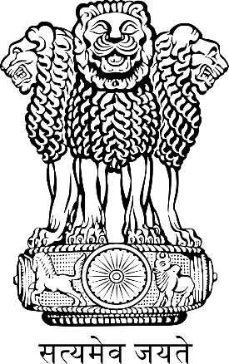 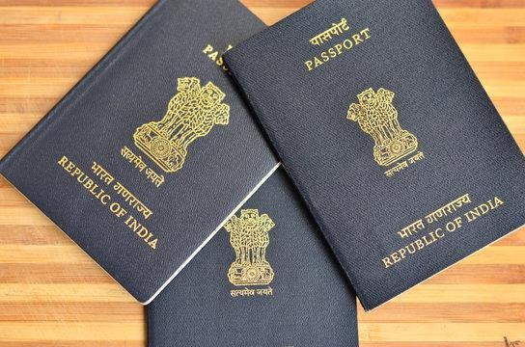

**Principle of Proportion in Visual arts.**

* Proportion refers to the dimensions of a composition and relationships between height, width and depth. How proportion is used will affect how realistic or stylized.
* Proportion also describes how the sizes of different parts of a piece of art or design relate to each other.
* Proportion in any art is the relative size of objects in relation to each other or corresponding to the other elements as a whole.

# **Basic Elements of a play.**

1. Theme - What is the meaning of theme in element of drama?

The theme refers to the message (meaning) that is intended to be expressed in the story. In other words, it is the main idea or the lesson to be learned from the story. Examples of themes in plays include: justice, loyalty. drugs, bullying, human rights etc.

1. Character- this is a person or individual taking part in the play or drama that may have defined personal qualities and/or histories.
2. Plot- A plot is a sequence of events within a play that tells a story. A plot is what makes a story. Five components make up a plot: exposition, rising action, climax, falling action, and resolution. Conflict and theme help drive the plot forward.
3. Language- Language in drama is represented as spoken language or, in other words, as speech. In drama, language refers to the particular manner of verbal expression, the diction or style of writing, or the speech or phrasing that suggests a class or profession or type of character.
4. Setting- The setting is the time and place in which the story takes place

# **Elements of Music in Creative Arts.**

* Sound-any tone with characteristics such as controlled pitch and timbre
* Rhythm- Rhythm is the pattern of sound, silence, and emphasis in a song
* Melody- a melody is a combination of pitch and rhythm.
* Harmony-harmony, in music, the sound of two or more notes heard simultaneously.

# **Elements of Dance in Creative Arts.**

1. Body - In dance, the body is the mobile figure or shape, felt by the dancer, seen by others. The body is sometimes relatively still and sometimes changing as the dancer moves in place or travels through the dance area. The body is the mobile instrument of the dancer and helps inform us of what is moving.
2. Action – This is what a dancer does, for example travelling, turning, elevation, gesture, stillness, use of body parts, floor-work and the transference of weight.
3. Space – Space refers to the area through which the dancer's body moves.
4. Time - It is an essential part of choreographing and performing dance. It helps us to stay together when we dance in unison, identify the beat and the rhythm of how we move and provide stimulus for choreography.

**WEEK 2**

**STRAND 2 CREATING & PERFORMING IN CREATIVE ARTS & SPORTS.**

2.1 Composing Rhythm

To understand and be able to write rhythmic patterns dictated, one needs to follow the following tips:

* + Establish the beat of the rhythm patterns.
  + Clap or tap the full rhythm before you start writing.
  + Break down the rhythm into bars and write one bar at a time while clapping the whole rhythmic pattern.
* Clap through the rhythmic pattern you have written to check if it conforms to the rhythm dictated.
* Creating involves coming up with a rhythmic pattern that has not existed before.

**A rhythmic pattern needs to be:**

* Balanced- each of the four bars should have notes adding up equally as per the time signature given or selected in simple time.
* Unique-be as creative as possible. Explore the different note values that you have so far learnt to bring in new ideas.
* Simple- it should be easily performed, interpreted and memorable. Use simple note values.
* Variety- use different note values, tied notes, dotted notes and rests to make the pattern more interesting.

**Dictation**

* Dictation is the art of listening and writing down correctly the played rhythmic patterns.
* For you to be able to write from dictation, you need to:
* Maintain the given pulse, tempo or speed.
* Be keen to keep it steady as the playing is going on.
* Tap back the played rhythm patterns as played.
* Sing it back using French rhythm names and memorize the pattern as played.
* Write out the played pattern.
* Listen again as you follow to confirm that what you have written is what has been played.
* It is always important to pay keen attention to the given instructions, because from them you get the time signature and how fast the rhythm will be played.

**Improvising rhythmic accompaniments with dotes notes in simple time.**

* Improvising is creating an additional feel, in this case, a different corresponding rhythmic pattern to what is already given.
* To accompany is to play different rhythmic patterns alongside an already given rhythmic pattern. This happens spontaneously (suddenly) without practice. It should come from within oneself.
* The following are some software for the different digital applications you can install for more practice:
  + Rhythm trainer.
  + Tap and learn.
  + Metronome and tuner.

**WEEK 3**

**2.2 Athletics.**

**Middle distance races.**

* Middle distance race starts with a standing start, athletes start from an upright, standing position the crouch forward with one foot about 18 inches behind the other.
* The leading foot and shoulder both point forward.
* The upper body should not be twisted.

**Strategies applied by middle distance runners during a race:**

* + Pacing.
  + Stride length
  + Recovery.

Pacing – rate at which an athlete runs. An athlete knows how long it takes him or her to cover a certain distance.

Stride length – it is the uniform length of steps taken during running.

Recovery - It is a stop, walk or slow jog made after striding.

It helps an athlete to catch a breath and relax before striding again which helps in developing speed and running skills.

**Photomontage.**

* Photomontage is the process and the result of making a composite photograph by cutting, gluing, rearranging and overlapping two or more photographs into a new image.
* It is assembly of images that relate to each other in some way to create a single work or part of a work of art.
* photomontage is an image constructed from collaged photographs.

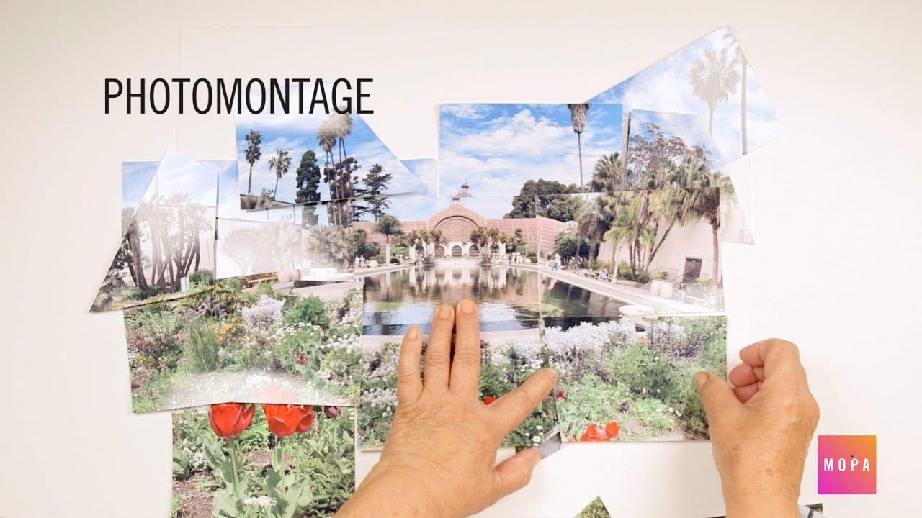

**Characteristics shown in photomontage.**

* Superimposition-combine two images to create something new.
* Use of pictures.
* Emphasis on shape.